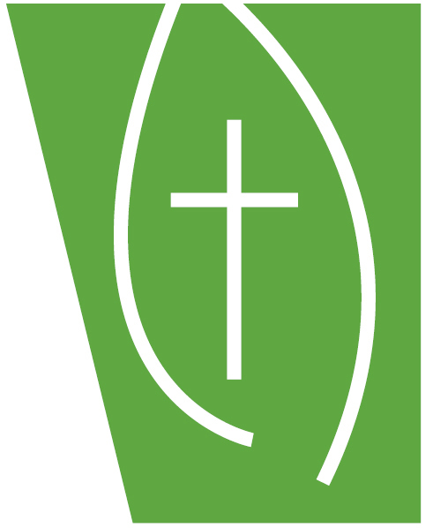
Presbytery of New Covenant
January 1, 2025—December 31, 2025
Budget Pledge of Undesignated Church Giving

We appreciate the generous support that we receive from our congregations!

From Church: ____________________________________City:______________________________

General Operating Budget Gift 1/01/25-12/31/25 for The Presbytery of New Covenant

Amt. to be sent Monthly $ _____________ Amt. to be sent Quarterly $_____________

Total of $______________ to the Presbytery of New Covenant General Operating Fund.
This supports the work of the presbytery.

General Assembly Per Capita for 2025 = $10.84 x 2023 Active Church Membership
Please note: This amount was set by the 226th General Assembly at its 2024 meeting in Salt Lake City.

Amt. to be sent Monthly $_____________ Amt. to be sent Quarterly $_____________

Total of $______________ for Per Capita. This is sent directly to our offices in Louisville to support the work of the denomination.

Please be sure to fill out the remittance form including how to allocate funds when sending a check to the Presbytery. If not specifically stated, all funds will go into General Operating Fund.

Submitted By: ___

Position/Office:_______

Please send the Completed Form to: The Presbytery of New Covenant
Attn: Charlie Leibold
4803 San Felipe
Houston, TX 77056-3907

FAX: 713-526-8814
Email: cleibold@pbyofnewcovenant.org

