

handbook
For
Clerks of Session

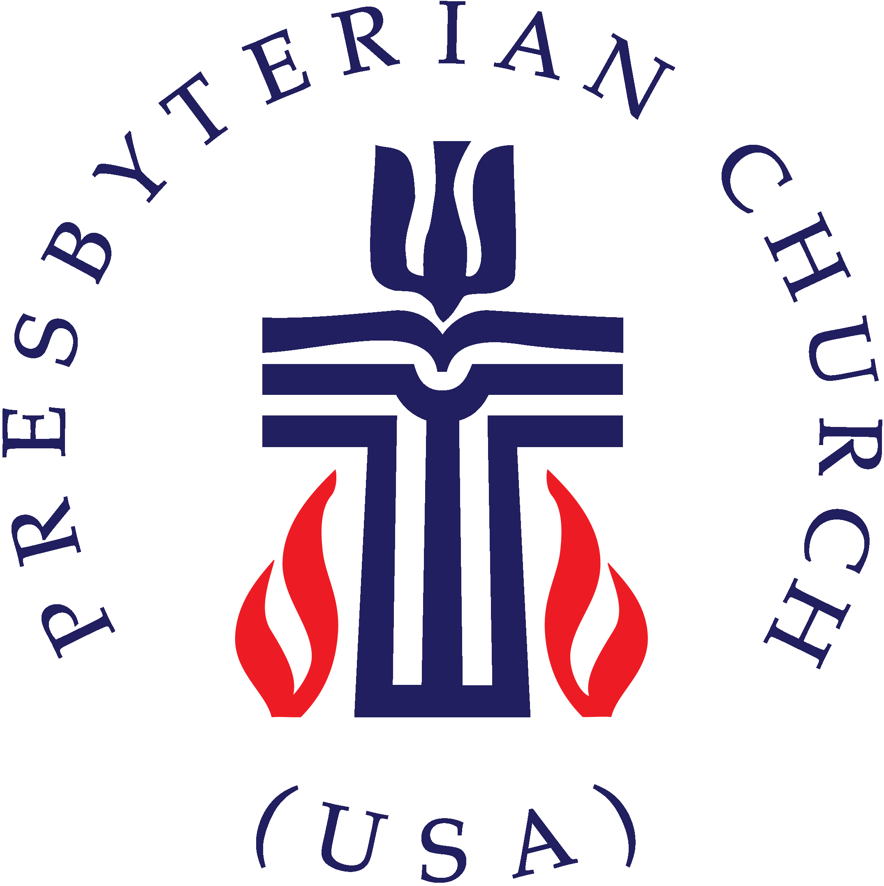

Table of Contents

Introduction 2
The Office of the Clerk of/to Session 3
Responsibilities at a Glance 4-5
Sample Session Docket/ Agenda……………………………………………………………………………..6
Guidelines for Session Minutes 7-9
Clerk’s Annual Report 10
Nuts & Bolts of Session Minutes 11
Sample Minutes of Session Meeting…………………………………………………………………..12-13
Congregational Meetings 14
Sample Minutes of Congregational Meeting…………………….………………………………….15-16
The Session's Relationship to Other Organizations……………………………………………..17-19
Actions that must be approved by more than one council…………………………………………20
Relations with Other Councils…………………………………………………………………………22-24
Annual Statistical Report 25-26
Other Information………………………………………………………………………………………………..27
Ruling Elder Commissioners to Presbytery………………………………………………………..27-28
Writing a Manual of Operations…………………………………………………………………………….29
Sexual Misconduct Policy/Anti-harassment Policy…………………………………………………30

Appendices……………………………………………………………………………………………………. 31-54
I. A Full Financial Review Defined 31
II. Resources for Review of Church Rolls……….………………………………………………. 32-34
III. Book of Order Exercise…………………………….………………………………..……….……..35-36
IV. Elders as Spiritual Leaders……………….…………..……………………………………………37-40
V. Other Helpful Resources 40-41
VI. Helpful People 41
VII. Books and Online Resources…………………………………………………………………… 42-44
Articles from The Presbyterian Leader………………………………………………………………45-54

Introduction

Welcome to the office of Clerk of Session! You have joined a unique and important group of people in the Presbyterian Church (U.S.A.). The Book of Order mandates that each governing body of the PC(U.S.A.) have a moderator and a clerk. Clerks of Presbyteries, Synods, and the General Assembly are called Stated Clerks. Those serving Sessions are called Clerks of Session or Clerks to Session. This depends on whether you are currently serving on Session or not.
As clerk, you will record a good deal of the history of your church as you write the session minutes. Future generations will learn what your church did to further Christ’s mission in the world by reading the minutes you write. It follows then, that it is important that you keep accurate records of all the proceedings in session meetings and in congregational meetings.
This handbook has been prepared to provide Clerks of Session with information and examples to assist them in their work and to insure that they have easily accessible information about what must be included in the session record books.
This handbook has been prepared by drawing on information in the Book of Order and in various manuals for clerks of session throughout our denomination. Special appreciation is noted for the work of Elder John Bolt, former Stated Clerk for the Presbytery of West Virginia, and Teaching Elder Ken Hockenberry, Stated Clerk of Chicago Presbytery.
If you have any questions, or need assistance, please contact me at the presbytery office (lhargrove@pbyofnewcovenant.org).

Lynn R. Hargrove
General Presbyter + Stated Clerk for Administrative Process
Presbytery of New Covenant

The Office of the Clerk of/to Session

The Clerk of Session shall be an elder elected by the session for such term as it may determine. The clerk may be a member of the session, or may be an elder not currently serving. If the clerk is not a member of session, general privilege of voice may be given by session but s/he may not make motions or vote. Session may ask the clerk to be its parliamentarian and in all cases shall give the clerk voice in matters pertaining to the minutes and the clerk’s report.
The person chosen to be clerk of session needs to be knowledgeable about session responsibilities, to have an understanding of Presbyterian polity, and be willing to learn basic parliamentary procedure. S/he must be able to write a clear record of the proceedings at session and congregational meetings and make those minutes available promptly following the meeting.
When the pastor or elders need a strong lay leader, the clerk of session is the “first among equals.” This responsibility flows to the clerk not because of any explicit statement in the Book of Order, but because the officer who receives the correspondence, keeps the records, and routinely discusses the work of the session with the pastor and all of the committee chairpersons to form the agenda and refer business, is the officer to whom they would take a problem. Presbyterian polity does not provide for any other lay officer to carry out these responsibilities.
In spite of the fact that the core functions of the clerk are secretarial, the session, in electing a clerk should seriously consider the qualifications needed to carry out the very significant “silent” functions of being the primary administrative officer of the congregation.

Responsibilities at a Glance
Annually
- Complete the annual statistical report (see Pages 24-26) requested by the General Assembly accurately and report to the PC(U.S.A.) by the deadline noted. Also, return other paperwork requested by the presbytery’s stated clerk by the deadline noted (Supplemental Report, Members of Session form, Necrology Report).
- Have your Session Records Reviewed with your fellow clerks, choosing a date and time from those set by the stated clerk of the presbytery. Bring your minutes since your last review. Include a copy of your Bylaws and Articles of Incorporation and your congregation’s required policies (see G-3.0106).
- Communicate dates and other information on Presbytery meetings to the Session so that ruling elder commissioners can be elected. Typically, the presbytery meetings are held on the third Saturday of March, July and November.

Monthly
- Send meeting notices by mail or email.
- Contact committee chairpersons about unfinished and referred business.
- Ask for recommendations to be in writing.
- Develop the docket or agenda for the meeting with the moderator.
- Record the minutes of each meeting. It is 30helpful to use a template with room to take notes and minutes. This should be a full and accurate record of the proceedings of the session (G-3.0204).
- Keep the roll of session membership and attendance (G-3.0104). The session shall “provide by rule” the number present for a quorum. (G-3.0203)
- Bring all official correspondence to the attention of session, and respond as directed by the session.
- Keep a list of unfinished business, including all matters referred to a committee or a staff member for later report to session, and remind the appropriate persons(s) if not reported expeditiously.
- In consultation with the moderator, prepare a statement of highlights of session actions and reports following the meeting for information for the congregation (may be included in the next issue of the congregation’s newsletter). Note: confidential matters should not be included.

Ongoing
- Arrange for the careful preservation of session records (G-3.0104), making recommendation to the session for the permanent safe-keeping of its records (G-3.0107).
- Furnish extracts from the minutes when required by another governing body of the church (G-3.0104).
- Maintain and preserve rolls and registers required of session (G-3.0204a&b). (See Rolls and Registers, page 11.)
- Be responsible for the preservation of the records of the Board of Deacons and the Board of Trustees (G-3.0107).
- Be familiar with the responsibilities of the session as described in the Book of Order (G-3.0201).
- Be prepared to respond to questions of parliamentary procedure in meetings if requested to be parliamentarian. (Meetings shall be conducted in accordance with the most recent edition of Robert’s Rules of Order, except in those cases where the Book of Order provides otherwise (G-3.0105). Copies of Robert’s Rules of Order and the latest Book of Order should be available at meetings.)

As needed
- Notify the session or congregation of special meetings, describing accurately the business that will be transacted. Congregations shall provide by their own rule for minimum notification requirements and give notice are regular services of worship prior to the meeting (G-1.0501 and G-1.0502).
- Serve as secretary for meetings of the congregation (G-1.0505), seeing that the minutes are received by session and are inscribed in the permanent session minute book. It is helpful to have the congregation delegate to session the authority to approve minutes of the congregational meetings, but these minutes should be posted for the congregation to see.
- Receive and submit communications from/to other governing bodies.
- Notify the stated clerk of the presbytery of changes in the membership of session.
- Assist the moderator in preparing the agenda for session meetings, as requested.
- Assist in church officer training when requested.
- May moderate the congregational meeting, if requested by the moderator, during the pastor’s salary review. If this occurs, a temporary clerk should be appointed.
- Perform such other duties as may be assigned by the session or moderator.


HELPFUL HINTS
Written reports facilitate the meeting flow.
Meeting may be informal, but all actions must be approved.
Each member of session should receive a copy of the minutes
soon after the meeting.

Sample Session Docket/Agenda

Your Presbyterian Church
Stated Session Meeting
Month Date, Year

Call to Order, Declaration of Quorum and Opening Prayer

Approval of the Docket and the Minutes of the previous stated meeting

Communications

Clerk’s Report
Session class of (year) was ordained and installed at the 11:00 am worship service on (Date): list their names
Lord’s Supper was celebrated at the 11:00 am worship service on (dates)
Membership report – transfers, deaths, marriages, baptisms

Session Committee Reports
Action Items

Old and New Business

Spiritual and Pastoral Concerns

Motion for Adjournment and Closing Prayer

************
The docket or agenda for a session meeting can be the responsibility of either the clerk or the moderator working together. In some instances, it is compiled by the church secretary. Input from the moderator and other members of session is invaluable. In the case of a pastoral vacancy, the moderator named by the presbytery often will rely on the clerk of session to formulate the docket.
Session dockets should be made available to session members prior to meetings so that the elders may be prepared to do the business of the church. Included in this information are the date, time, location, agenda or order of business, financial data, and other pertinent information as needed and available.
The value of a printed docket or agenda is three fold:
It provides for an orderly process in the handling of session business.
It informs the members of issues to be discussed.
It serves as a reminder of the necessary preparation for a meeting.
The clerk of session can take this opportunity to assist the moderator in handling administrative details and sharing in the ministry of the church.

Guidelines for Session Minutes

Minutes of each session meeting shall (i.e., must include:
  - Whether the meeting is a regular or special meeting.
- The name of the church, the place, date and time of the meeting.
- The name of the moderator of the meeting.
- The opening and closing of each meeting with prayer.
- The roll, listing elders present, elders absent and any who are excused; the clerk, moderator and other staff present or excused; others present and their identity. (Please use first and last names.)
- The affirmation of a quorum (G-3.0203). NEW: Sessions shall provide by rule for a quorum for meetings; such a quorum shall include the moderator and either a specific number of ruling elders or a specific percentage of those ruling elders in current service on the session.
- The approval of the agenda. (In case of a special meeting, the call to the meeting stating the purpose becomes the agenda.)
- The approval of the minutes of the previous meeting. (Any corrections of previous meeting minutes shall be listed, and then corrected in the prior meeting’s minutes.)
- Clerk’s report: may include correspondence, announcements, and report of the serving of the Lord’s Supper, in addition to listing of baptisms, marriages, changes in membership rolls.
- Reports of pastor, other staff, the treasurer and committee chairpersons should be summarized in the minutes.
- All motions and amendments, if any, and whether they passed or failed. (Details of discussion should not be recorded, except when needed to give a sense of the action.)
- When a previous action of the session is referred to, the page on which it is recorded, or the date of the meeting at which it occurred, should be designated.

Minutes shall include the following, when applicable:
13. Requests for marriage, baptism or funerals to occur in the church.
14. The administration of the Sacrament of the Lord’s Supper must be reported at the next succeeding regular meeting. When the sacrament has been administered to those unable to attend public worship, the name of the minister officiating and the name of the elder or elders assisting should be noted. (This may be part of the clerk’s report, the pastor’s report or that of the worship committee.)
15. The administration of the Sacrament of Baptism must be reported at the next succeeding regular meeting, giving the full name of adults baptized including the maiden name of married women; the record of infants baptized, noting the name of the child, date of birth, and the names of the parents or the one rightly exercising parental responsibility (W-2.3014), and including the mother’s maiden name. (This may be part of the clerk’s report, the pastor’s report or that of the appropriate committee.)
16. The full name of applicants for church membership (in the case of married women, include maiden name) and the manner of their reception:
      - by profession of faith, previously baptized 2. by profession of faith and baptism
3. by re-affirmation of faith 4. by letter of transfer, giving the name of the church
from which received
17. The name of the church to which a certificate of transfer is granted and the full name of the person transferred with the date of transfer, together with names of baptized children, if applicable.
18. Record (attach to minutes) the job descriptions for employed personnel, both clergy and non-clergy, as they are approved.
19. Name of elders elected to be commissioners to meetings of the presbytery, and the exact period for which elected (G-3.0202(a.)).
20. Record that commissioner(s) to the presbytery reported to session. The report may be summarized.
21. When the session finds it necessary to exercise discipline, the “Form of Government” and the “Rules of Discipline” should be carefully studied by a committee of the session and if discipline be administered, the minutes of the session must contain such a record of the proceedings which will enable the Presbytery to know who was disciplined, why and how. It is most often advisable for session to ask the presbytery to take jurisdiction of any matter of church discipline.
22. In case of a sale, mortgage, gift or lease of property, the session records must show: 1. Name, address and legal description of the property
2. Name of buyer/lessee
3. Sale price
4. Loan amount purpose and terms, including the name of the lender
5. Lease terms and liability insurance
6. Concurrence of Presbytery

Be sure the following is included each year:

1. Approve of the annual budget.
2. Approve of the distribution of the church’s benevolences.
3. Record the annual review with each pastor of the adequacy of compensation.
4. Record the recommendation to be made to the congregation for changes in the terms of call for each pastor.
5. Note the annual review by the personnel committee (or other responsible body appointed by the session) of the adequacy of compensation of all paid staff.
6. Note whether new officers have received training and been examined (G-2.0402).
7. Report the ordination and/or installation of elders and deacons at the next succeeding meeting.
8. Report the recognition of trustees (if any) at the next succeeding meeting.
9. Report that property and liability insurance has been obtained (G-3.0112). (Insert photocopy of the church’s certificate of insurance.
10. Record report of annual financial review or audit.
11. Record marriages, births, deaths.
12. Record election of clerk and treasurer.
13. Record annual review of church rolls and if anyone is moved to inactive or removed.
14. Report reception of new members; dismissal/transfer of members to other churches.
15. Record approval of curricula, teachers for the educational program.
16. Attach copy of Annual Statistical Report (to OGA) to minutes.

Clerk’s Annual Report
At the last meeting of each calendar year, please include the following in the Clerk’s Report:

1. Record that job descriptions have been approved for all employed personnel, both clergy and non-clergy, and indicate by page number where the latest job description for each staff person is located in the minute book.
2. Record changes during the year in the Session, the Board of Deacons and the Trustees through death, resignation, or removal.
3. State the composition of the session with regard to racial ethnic members, women, men and age groups, and how this corresponds to the composition of the congregation. (This requirement may be fulfilled by photocopying the annual statistical report required by the General Assembly into the session records.)
4. If congregation has a Board of Deacons and/or Trustees, report in the minutes where their records are kept, and that they have been reviewed by session.
5. Include an Annual Narrative Report. (Moderator’s annual report, or periodic reports to the session of ongoing church life will satisfy this request.)

Nuts & Bolts of Session Minutes
The method of recording session minutes is somewhat dependent on local circumstances. The following is the suggested procedure used by the majority of churches:
1. Clerk takes notes for the minutes at meeting.
2. Clerk writes the minutes and types or arranges for them to be typed.
3. Clerk makes copies and distributes before the next meeting;
4. At the next meeting, the minutes are either approved as distributed or corrections are made and the corrections are noted in that meeting’s minutes (as well as originals);
5. Clerk types or arranges for someone to type approved minutes in the session permanent minute book (these may be photocopied as long as archival quality paper is used);
6. If using a computer for minutes in the permanent minute book, a laser printer and archival quality paper must be used;
7. If you wish, 200-250 pages may be professionally bound into volumes. This can be done by the Presbyterian Department of History at a reasonable cost (215) 627-1852.
8. Do not use erasures, whiteout, strikethroughs or footnotes; or insert in the records separate sheets of paper with written or printed matter on them.
9. The records of each session meeting are to be duly attested (signed in ink) by the clerk. The records of congregational meetings are to be attested by the clerk AND the moderator.
10. The minutes of congregational meetings, the annual report of the church treasurer or treasurers, and the annual statistical report required by General Assembly are to be included with session minutes. These are to be typed or photocopied into the permanent record book.
11. Minutes should be interesting, with enough information so that future generations will know what happened in the church years before. The minutes play a role in recounting the history of the congregation, often retrievable in no other way.
12. The minutes of a meeting should never reflect the clerk’s opinion, favorable or otherwise, on anything said or done.
13. Session minutes should be available to any member who asks.
14. It is recommended that a “church office copy” of session and congregational meeting minutes be kept in a notebook for handy reference. Typically this is not the set of minutes to be reviewed by presbytery.

SESSION meeting minutes must be attested (signed in ink) by the clerk.
Sample Minutes of Stated Session Meeting
Your Presbyterian Church
Month Day, Year

The Session of Your Presbyterian Church held its Stated Meeting in the church library on (Month Day, Year) at (Time). The meeting was called to order by Moderator (Name), who declared a quorum was present and opened the meeting with prayer.

Attendance: Ruling Elders (name), Visitors (name), Moderator (name), Excused (name)

Docket: It was moved and seconded that the docket be approved. The motion was approved.

Minutes: It was moved and seconded that the minutes of the Stated Meeting of (date) be approved as written (corrected); motion approved.

Communication: A letter was received from the Stated Clerk of the presbytery requesting the names of any elders or deacons who died in the past year for the presbytery’s necrology report.

Clerk’s Report:
Membership updates
Deaths
Weddings
Baptisms
Other information

Committee Reports: (indicate any actions taken)

Christian Education: requested approval for the elementary students to use the “We Believe” curriculum in Sunday School. The motion was approved.

Finance: reported that pledges received exceed last year at this time.

Worship: requested approval for communion to be served at the church retreat at Mo-Ranch. The motion was approved.

Property: reported that bids for a new air conditioner are being received and be brought to the next meeting for approval.

Old and New Business:

Report from commissioners to the presbytery meeting: A & B attended the presbytery meeting held at First Presbyterian on (date). They recommended the keynote speaker, and were pleased to hear of the new worshipping communities in the presbytery.

Financial Review Committee Report: The chairperson of the Financial Review Committee reported that the 2013 financial records of the church have been reviewed by the committee. No discrepancies were found, and the following recommendations were made: ______________________.

Spiritual and Pastoral Concerns:
Requests for prayer were made for L&M and the birth of their baby; for M&E who are having marital difficulties; for P who lost his job and is seeking employment; for the teachers at the pre-school as the director just quit.

Motion for Adjournment and Closing Prayer:
There being no further business to come before the meeting, it was moved and seconded that the meeting be adjourned. The motion was approved. The meeting was closed at (time) with prayer led by (name).

Respectfully submitted,

(Name)
Clerk of Session

Congregational Meetings
Congregational meetings may be called by the session, the presbytery, or by session by written request of one-fourth of the members of the congregation on the active roll. (G-1.0502) Your congregation’s by-laws should include what constitutes a quorum. (G-1.0501) Proxy voting is not permitted in church meetings. We believe that the Holy Spirit guides us in our decision making, and one must be present in the room to be open to such guidance by the Spirit. Be prepared for a ballot vote if needed. Minutes of all congregational meetings shall be included in the session record book along with session minutes in chronological order.

Minutes of these meetings shall include:

- Indication of whether the meeting is “regular” or “special.”
- If it is a “special meeting,” the minutes shall include the call to the meeting, which will serve as the agenda.
- Name of the church.
- Date, time, and place of the meeting.
- Name of the moderator or presiding officer.
- Presence of a quorum.
- Opening and closing of the meeting with prayer.
- Record of all actions, whether adopted or lost.
- When applicable, action by the congregation on any change in each pastor’s compensation, with terms of call specified.
- Minutes of the meeting of the congregation and corporation at which the annual financial reports are made should indicate, at least:
  - report of a full financial review of the financial records (G-10.0400d) (formerly referred to as “audit”) (See Appendix)
  - a complete, itemized report of income and expenditures for the year
  - provide the complete, itemized proposed budget adopted by the session for the coming year
  - details of the status of loans from General Assembly, Synod, or Presbytery, if any are outstanding
- If the congregation does not approve the minutes before adjournment, session may approve the minutes at its next scheduled meeting.

Congregational meeting minutes must be attested (signed in ink) by the moderator and the clerk.
Sample Minutes of the Annual Congregational Meeting
Your Presbyterian Church
Date

The congregation of Your Presbyterian Church was called to meet on Sunday, (date), immediately following the 11:00 am worship service. The meeting was called to order by the Pastor/Moderator (name) who opened the meeting with prayer.

Clerk/Secretary: (name) was present and served as secretary. The clerk advised the moderator that a quorum was present. The moderator agreed. The clerk reminded everyone of the voting eligibility for this meeting.

Reading of the Call (for Special or Called Meeting) … the call was found to be in order.

Approval of the Docket: The docket was found to be in order and approved by consent.

Members who join the Church Triumphant in the last year: The clerk read the names of the members who died. They are … (names). The pastor offered a commemoration prayer.

Minutes of the Congregational Meeting(s) (for last year): The minutes of the Annual Congregational Meeting of (date) and the Called Congregational Meeting of (date) were distributed. They have been reviewed and accepted by the Session as an accurate reflection of the actions taken at those meetings.

Review of the “Summary for (year)” and (year) Annual Report Supplement: The summary for (year) and the (year) Annual Report Supplement (with Minutes, Statistical and Financial reports) were distributed and discussed by the congregation. Copies of the full Annual Reports were made available in printed and/or electronic means, and upon request. Members asked questions about these reports.

Review of the Session Approved Church Budget for (year): The treasurer, (name), reviewed the (year) Church Budget which was approved by the Session on (date). Questions were asked, opportunity was offered for any member to make any budget recommendations to the Session for their consideration.

Approval of the Change in the Pastor’s Terms of Call: The Session reviewed the Pastor’s Terms of Call and made the following recommendation for changes:
Past Year Proposed Amount
Salary $_______________ $__________________
Housing $_______________ $__________________
Expenses $_______________ $__________________
Board of Pensions $_______________ $__________________

This change in the pastor’s call represents a (number)% increase. The pastor spoke to these terms and left the room. The clerk assumed the chair. Discussion followed. The motion was approved. The pastor was welcomed back to the meeting with applause.

Congregational Nominating Committee: The Nominating Committee is comprised of two members from the Session, (one from the Deacons), and (number) from the congregation. The following persons were nominated to serve in the committee: (names). A motion was made to elect (names) to the Nominating Committee. The motion was approved.

Old/New Business: (note, if any)

Adjournment: There being no further business to come before the meeting, a motion was made and seconded to adjourn. The meeting closed at (time) with prayer by (name), and the singing of “Blessed Be the Tie that Binds”.

Attest:

_________________________ _______________________
Moderator Clerk/Secretary
The Session’s Relationship to Other Organizations

All organizations of the congregation are accountable to the session. All organizations should make a financial and programmatic report to session and the congregation annually.

G-3.0201 The Session: Composition and Responsibilities
… In light of this charge, the session has responsibility and power to:
  - Provide that the Word of God may be truly preached and heard.
  - Provide that the Sacraments may be rightly administered and received.
  - Nurture the covenant community of disciples of Christ … including directing the ministry of deacons, trustees, and all organizations of the congregation …

G-3.0106 Each council shall develop a manual of administrative operations that will specify the form and guide the work of mission in that council. All councils shall adopt and implement the following policies: a sexual misconduct policy, a harassment policy, a child and youth protection policy and an anti-racism policy. Each council’s policy shall include requirements for boundary training which includes the topic of sexual misconduct, and child sexual abuse prevention for its members at least every thirty-six months.

Board of Trustees: G-4.0101
…The powers and duties of the trustees shall not infringe upon the powers and duties of the session or the board of deacons.

Board of Deacons or Individual Deacons: G-2.0202
…Deacons may be individually commissioned or organized as a board of deacons. In either case, their ministry is under the supervision and authority of the session. Deacons may also be given special assignments in the congregation, such as caring for members in need …

Nominating Committee: G-2.0401
The church nominating committee is a committee of the congregation, not the session. It does not report to the session, although the committee may wish to consult with session, and provide updates on their progress to the session.
…Ruling elders and deacons shall be nominated by a committee elected by the congregation, drawn from and representative of its membership. Congregations may provide by their own rule for a congregational nominating committee, provided that the committee shall consist of at least three active members of the congregation, and shall include at least one ruling elder who is currently serving on the session. The pastor shall serve ex officio and without vote …

Pastor Nominating Committee (When there is a Pastoral Vacancy)
It is vital that the Session and any interim pastor work closely with the Committee on Ministry of the Presbytery, through the assigned transition team to the church, and the General Presbyter. This is one of the most significant ways the presbytery serves the local congregation – in the procedures and process guidance of finding a new pastor.

G-2.0801 Pastoral Vacancy
When a congregation has a vacancy in a pastoral position, or after the presbytery approves the effective date of the dissolution of an existing pastoral relationship, the congregation shall, with the guidance and permission of the presbytery, proceed to fill the vacancy in the following manner.

G-2.0802 Election of a Pastor Nominating Committee
The session shall call a congregational meeting to elect a pastor nominating committee that shall be representative of the whole congregation. The committee’s duty shall be to nominate a pastor for election by the congregation …

The pastor nominating committee is a committee of the congregation, not the session. The committee has several points of contact with the session and the presbytery:
- The pastor nominating committee develops the Ministry Discernment Profile (MDP) which includes the position description.
- The session and then the presbytery (through the Committee on Ministry) approve the MDP.
- The committee negotiates the salary of the new pastor in consultation with the session/board of trustees.
- The General Presbyter does a reference check on the final candidate(s) for the position.
- The committee requests session to call a congregational meeting when it is ready to bring a candidate.

Session and Personnel Committee: G-3.0102 Ecclesiastical Jurisdiction
[Councils, like the session] … They have the power to establish plans and rules for the worship, mission, government, and discipline of the church and to do those things necessary to the peace, purity, unity, and progress of the church under the will of Christ. They have responsibility for the leadership, guidance, and government of that portion of the church that is under their jurisdiction.

The session supervises all ordained and non-ordained personnel, often through a Personnel Committee. The session recommends to the congregation the “Terms of Call” (salary, including housing, benefits, etc.) of all ordained personnel; the congregation approves these terms of call or any subsequent future changes in the terms of call annually. The terms of call must meet the minimum guidelines set by presbytery unless a waiver is granted.

It is recommended that the Personnel Committee for each church consist of a majority of session members, and several congregation “at large” members.

Outside organizations
Session controls the use of all church property, including granting permission for the sanctuary to be used for weddings. The purpose of an organization using the church should not be contrary to the mission of the congregation or the Presbyterian Church (USA). It is wise to have a written contract for all organizations using the church building, stipulating any rental fee, maintenance standards, and rooms of the church to be used.

G-4.02 Church Property (summary)
All leases for a period of 5 years or longer must be approved by the presbytery. Any sales contract for property owned by the congregation/church must be approved by the presbytery. Any contract to purchase property must be approved by the presbytery.

Whenever a congregation is formally dissolved by the presbytery, or has become extinct by reason of the dispersal of its members, the abandonment of its work, or other cause, such property as it may have shall be held, used, and applied for such uses, purposes, and trusts as the presbytery may direct, limit, and appoint, or such property may be sold or disposed of as the presbytery may direct, in conformity with the Constitution of the Presbyterian Church (U.S.A.).

Actions that must be approved by more than one council
One of the hallmarks of the Presbyterian Church (USA) is its connectional system. There are a number of actions that require approval beyond the session. Among them are:
- Application to presbytery to take an inquirer under care of the presbytery: session, Committee of Preparation for Ministry, and presbytery.
- Loans that use the church or its property at collateral for a mortgage, and all sales of property: session and trustees, trustees of presbytery, and presbytery (ecclesiastical and corporate). These also require the initial approval of the congregation.
- All leases of church property for a period of more than five years: session, Finance Committee of presbytery, and the presbytery.
- All changes of church location or church name: session, congregation (ecclesiastical and corporate), Committee on Ministry (COM) of presbytery, and presbytery (ecclesiastical and corporate).
- All changes in the annual terms of call for the pastor: session recommendation, congregational approval, Committee on Ministry, and the presbytery.
- Dissolutions of pastoral calls and calls for new pastors: congregation, Committee on Ministry, and presbytery.
- Appointment of moderator of session, or temporary pastoral relationship: session, Committee on Ministry, and presbytery.
- Call for a special session meeting when requested by two members of the session in writing. (G-3.0203)
- Call for a special congregational meeting: session, or presbytery, or session when requested in writing by one-fourth of the active members of the congregation. (G-1.0502)
- Session meeting when a pastor is ill or out-of-town: pastor grants permission and appoints a member of presbytery as moderator pro tem. (G-3.0201)
- All waivers from the Book of Order terms of election (g-2.0404): congregation, Committee on Ministry, and presbytery.

Relations with Other Councils G-3.0202
Sessions have a particular responsibility to participate in the life of the whole church through participation in other councils. It is of particular importance that sessions:
- Elect, as commissioners to presbytery, ruling elders from the congregation, preferably for at least a year, and receive their reports.
- Nominate to presbytery ruling elders from the congregation who may be considered as commissioners to synod and General Assembly, and to serve on committees or commissions of the same …
- See that the guidance and communication of presbytery, synod, and General Assembly are considered, and that any binding actions are observed and carried out.
- Welcome representatives of the presbytery on the occasions of their visits.
- Propose to the presbytery, or through it to the synod and General Assembly, such measures as may be of common concern to the mission of the church; and
- Send to presbytery and General Assembly requested statistics and other information according to the requirements of those bodies, as well s voluntary financial contributions.

Rolls and Registers

Rolls
The Rolls of the church should contain information about those who are members of the local church. It is the responsibility of the Clerk of Session to maintain, or to oversee the maintenance of the Rolls as required in G-3.0204a.
- Names of members shall be placed upon, removed, or deleted from the rolls of the church only by order of the Session (G-3.0204a)
- Session shall maintain the following membership rolls (G-1.04):
Baptized Members (G.1.0401)
A Baptized Member is a person who has received the Sacrament of Baptism, whether in this congregation or elsewhere, and who has been enrolled as a baptized member by the session by who has not made a profession of faith in Jesus Christ as Lord and Savior. Such baptized members receive the pastoral care and instruction of the church, and may participate in the Sacrament of the Lord’s Supper.
Record the name, date of baptism (if known), church where Sacrament of Baptism occurred. Names should be removed from this roll when profession of faith is made, or when the person moves from the community.

Active Members (G-1.0402)
An Active Member is one who has made a profession of faith in Christ, has been baptized, has been received into membership of the Church, has voluntarily submitted to the government of the particular church, and participates in the church’s work and worship.
Record name, date received into membership, and method of reception. Record date of removal from the particular role and whether by death, transfer to another church, placed on inactive roll, or removed.

Inactive Members (This category is no longer in the Book of Order)
You are not required to keep a roll of Inactive Members, but you may if you want. An Inactive Member is one who no longer participates in the church’s work and worship.
Record name, date; indicate if inactive member is subsequently removed or reinstated with date of action. (See Appendix for additional information on roll review.)

Affiliate Members (G-1.0403)
An Affiliate Member is a member of another congregation of this denomination or of another denomination or Christian body, who has temporarily moved from the community where the congregation of active membership is situated. A certificate of good standing from the appropriate council or governing body of that congregation should be presented. The person will be received by the session as an Affiliate Member. An Affiliate Member is not eligible to be elected to ordered ministry or other office in the congregation, and does not have a vote in congregational meetings. An example of an affiliate member would be a college student living in your community while attending school.
Record name, date of affiliation, name of home church, date of renewal, date of return to home church.
Roll books usually provide double pages for a chronological roll by date of reception into membership with columns for name, how received, name of church from which member transferred if that is the manner of reception, date of deletion from the active roll and reason—by death, inactivity, or transfer, in which case the name of the church to which the member is transferring is listed.
Pages may be provided in the same binder for an alphabetical listing of members along with the membership number that is assigned in the chronological roll.
Pages also may be provided for Baptized, Affiliate and Inactive member rolls in the same binder.
Pages containing columns for the information requested may be obtained through Cokesbury, (800) 672-1789 or www.cokesbury.com

Registers
Registers are historical records and need to be carefully maintained. It is the responsibility of the Clerk of Session to maintain or oversee the maintenance of Registers as required in G-3.0204b. All information in the Register should be able to be cross-referenced to the minutes. Please do not erase, cross out, or use “white out”. Use the remarks section to make any changes.
According to the 2013/2015 Book of Order, there shall be registers of baptisms authorized by the session, of ruling elders and deacons, of installed pastors with dates of service, and such registers as the session may deem necessary. These are suggestions for information for the register:

Baptisms
Register of Infant and Adult Baptisms shall include name, parents’ names, and date of birth of those being baptized.

Elders
Register of Elders shall include each elder’s name, the name of the church in which each was ordained, date of ordination, terms of active service, and record of removals.

Deacons
Register of Deacons shall include each deacon’s name, the name of the church in which each was ordained, date of ordination, terms of active service, and record of removals.

Pastors
Register of Pastors shall include the names of pastors, co-pastors, associate pastors, assistant pastors, interim pastors, stated supplies, and parish associates serving the church, with dates of service.

Although no longer required by the Book of Order, you might want to keep a register of marriages. If so, here is suggested information:

Marriages
Register of Marriages shall include marriages of members of the church, all marriages conducted by the ministerial staff of the church, and all marriages performed on church property.

All registers may be kept in the same binder, or in the binder with the rolls. You may use the Westminster Binder, or simply use a loose-leaf notebook. Special pages for the Westminster Binder may be obtained through Cokesbury Book Stores (800) 672-1789 or www.cokesbury.com .

Annual Statistical Report

Introduction
The presbytery must make an annual report to the General Assembly, which specifies the type of information it needs. Much of the information is gathered from local congregations by means of the "Session Annual Statistical Report."
The data entered need not be perfect. The information is used to keep track of trends and much is expected to be subjective. Both the total active membership and the financial data for recent years are available on the General Assembly’s web site (www.pcusa.org) for all churches that complete the Report.
Some of the information requested can be difficult to obtain accurately (such as ages of members) and some information related to the budget may be requested in different categories than your bookkeeper has used. The report form comes with a workbook, which provides explanations of each item and provides a place to do a draft before transferring the figures to an online form.
Suggestions are made here to try to make the process easier. As with most jobs, keeping up on a monthly basis rather than waiting until the end of the year makes it easier. In addition, keeping up makes the total time spent less.
The form is divided into two main parts: Membership and Finances. For this discussion, Membership will be considered in two parts: active members and other data.
In order to collect the data, it is suggested that it be done regularly (each month) rather than waiting until the end of the year.
One way is to keep a notebook with pages labeled for various categories and enter the information after each Session meeting. This could also be done using Excel or setting up a table in MSWord.

Reporting Membership
The report gives the number of active members at the beginning of the reporting period.
Gains: Certificate gains are adults transferring their membership from another church. Youth Professions of Faith are typically those completing a confirmation class who are under the age of 17. Profession of faith (18 and older) or reaffirmation of faith are those who join the congregation who are not included in the first two categories.
Losses: Certificate would be those who transferred to another church. Death seems obvious. Deleted from the Roll for any other reason, which would include those who have been temporarily excluded or removed from active membership under a disciplinary process (D-10.0300), which is rare within a congregation.
Ending Active Membership is the total of gains and losses compared to the beginning membership.

Congregational Life
These data includes:
Baptisms – Infant/Children presented by others, at confirmation, adults
Weekly average worship attendance
Friends of the congregation – those who participate regularly but have not joined
Number of Ruling Elders on Session
Do you have Deacons?
Gender distribution – women, men, non-binary/genderqueer
Age distribution of members – 6 categories
Youth in the Congregation – 4 categories (Pre-school, Elementary, Middle and High School)
Disability and Racial Composition
Number of persons with disabilities (Hearing, Mobility, Sight, and other)
Racial ethnic composition of congregation
NOTE: If you are using some sort of computer membership system such as PowerChurch Plus or Ease, it is possible to keep track of some of these items through the proper use of the system. Years of birth of all members may not be known so you will need to make educated guesses in order to determine age distribution.
Look at the workbook for the definition of a person with a disability. This is not the usual definition. The definition is that the disability "substantially limits participation" but the application of the definition is left to you. Just as in age distribution, use of personal knowledge is expected to be applied rather than a formal survey. Data collected with such a vague definition cannot be worth very much so don’t worry about this too much; just do your best. A person in a wheel chair may not be “substantially limited”. That person can’t help set up tables for a church dinner but neither can the 95-year-old who lives alone and drives to church each week and serves on a church committee. Both of these describe persons in one church who would not consider themselves “substantially limited”.

Financial Data (in whole dollars)
The financial reporting is broken down into broad categories. The most important is the estimate of budgeted income and expenses. Note that the values to be reported are for the whole congregation. If there are several accounts in the main finances, all must be included. If groups within the church maintain their own accounts (such as Presbyterian Women, Building Fund, and so forth), all of these should be included if their finances are substantial. If these group’s monies are small, they can be ignored as long as you do this consistently over the years. The financial reporting is really looking for trends.
Per Capita Apportionment Payments: Many presbyteries and synods have a per capita apportionment to be used for ecclesiastical expenses. Presbytery of New Covenant and Synod of the Sun do not. This does not mean that per capita is not important. This is figured based on the number of church members multiplied by a figure provided by General Assembly. In 2025, the figure is $10.84. This can be remitted through the presbytery to the General Assembly.
Other Information
Annual Review of Terms of Call: Each year the Session is required by the Book of Order (G-2.0804) to review the adequacy of the salaries of all pastoral staff. If session wishes to make any change in the terms of call as they were last approved by presbytery, the changes must be brought to the congregation for approval, contingent upon the approval of presbytery that, finally, approves terms of call and all changes in terms of call. As soon as the congregation has approved new terms of call for its pastor(s), the terms of call forms must be returned to the Committee on Ministry for recommendation to the presbytery. These forms are available on the presbytery’s website www.pbyofnewcovenant.org under “Our Filing Cabinet” under the “Resources” tab.
Minimum Compensation for Pastors: The presbytery adopts minimum terms of call for all installed pastors. These terms are reviewed and updated annually. All terms of call must meet this minimum standard for presbytery to approve the call. This information is available on the presbytery’s website (see above).

Ruling Elder Commissioners to Presbytery

Presbyterian polity is representative. It works when each church takes seriously its responsibility to elect ruling elder commissioners who attend the meetings, stay through the end of the meeting, and report to session. Presbytery of New Covenant holds three regular presbytery meetings a year. The dates and times are published annually and are available on the presbytery’s website, www.pbyofnewcovenant.org under the tab “Presbytery Meetings”.

Each session is responsible for electing ruling elder commissioners to presbytery. The number of commissioners depends on the size of the congregation. The number of ruling elders to which a congregation is entitled also varies according to the presbytery’s Parity Plan. The Book of Order (G-3.0301) states that “the presbytery shall adopt and communicate to the sessions a plan for determining how many ruling elders each session should elect as commissioners to presbytery, with a goal of numerical parity of teaching and ruling elders. This plan shall require each session to elect at least one commissioner and shall take into consideration the size of congregations as well as a method to fulfill the principles of participation and representation …”

The docket and meeting packet are distributed prior to the meeting. This information should be given to the commissioners so that they can access the meeting materials, which can also be distributed to members of the congregation, as appropriate.

Commissioners are asked to report to session about the meeting, including significant actions taken by the presbytery; a summary of issues deliberated upon; policy decisions made; implications of presbytery actions for the congregation; concerns and opportunities open to the congregation through presbytery; and any other matter which will help with the congregation’s participation in the total ministry of Jesus Christ. “Presbyterian Postlude” is published after each meeting, and can be helpful in this report.

Session members, including presbytery commissioners, should bear in mind the opportunities and need for nominations to presbytery committees. We are committed to finding Presbyterians with skills and interests in serving on a presbytery committee, and welcome your suggestions. We strive for inclusion so that all voices are represented at the table. Please share the gifts of your congregation with the presbytery.
Writing A Manual of Operations

One of the changes under the New Form of Government (nFOG) was the requirement for each council to develop a manual of administrative operation that specifies the form and guide the work of mission in that council (G-3.0106). Prior to the Book of Order 2011/2013, this was required of those entities above the session. It now includes the session which is considered to be a council of the church.

A manual of operation differs from the church by-laws. Since it falls under the session, it does not need congregational approval, although input from congregation members in its writing might be helpful. Its purpose is to provide guidelines for how the structures of the congregation operate, especially in light of their Mission and Vision statements.

Introductory paragraphs might include a general description of the work of the congregation though the various committees/ministry teams (which would include the session). It could include a line saying, “The contents remain flexible allowing amendments and additions to be made as recommended by the committees and approved by the session.” How the details of the committee work are defined are up to the session.

A manual that uses more “guidelines” than hard and fast “rules” often makes it easier for the work of the church to be accomplished, and to become more “permission giving.” Using the word “ordinarily” instead of the word “shall” assists in that effort.

Committee/Ministry Team (C/MT) structure could include its membership composition (how many members, terms of service), and skills and abilities that are helpful in its work. It could address how meetings are convened – how often, face to face or electronically. It could outline how committee members are assigned tasks and how reporting is done. The tasks or functions of the C/MT could be included, whether written generally or specifically. A C/MT could be able to set up task groups as needed without having to revise the manual of operations.

Use of the property might be addressed. This could include the use by outside groups, who is responsible for maintenance and clean up, any costs for using the facility. Wedding and/or funeral policies could be included.

The manual of administrative operations should be the reference that answers questions about how we do things in this congregation. Each manual will be as unique as each congregation. Writing a manual of operations will help define the policies, procedures and practices of a congregation and to discern what is working and what might need to change. A question to ask is, “What do we need to do to do the work we are called to do?”

Sexual Misconduct Policy

The Book of Order 2011/2013 contained a new directive for all councils of the church which was to “adopt and implement a sexual misconduct policy” (G3.0106). Many have wondered how this differs from a “Child Protection Policy.” A sexual misconduct policy is broader in order to protect the whole congregation, and those outside as we engage our communities to make disciples.

Having a sexual misconduct policy gives people language and a framework for discussing these types of issues as an abuse of power. Recognizing that power is given by individuals and communities gives us a greater responsibility to ensure that no one is being abused or mistreated. A sexual misconduct policy helps us to set up appropriate boundaries in our ministry – defining appropriate friendships, counseling limitations, and the complexities of communication technology. No one on the church staff or in a position of leadership is exempt, nor should be the members of the congregation.

The sexual misconduct policy should include the basic principles of conduct and definitions of inappropriate behavior. Sexual misconduct can include sexual abuse including that with children, as well as sexual harassment.

How the church will respond to allegations of sexual misconduct would include reporting requirements as well as the response process. Prevention and risk management should be addressed in the policy, including issues of liability and insurance as well as employment practices.

Education and training is another area to include in the policy, in order to raise awareness of this problem. This could include the requirement for ministers, volunteers, elders, deacons, and staff to be trained, as well as how often.

Another area to consider is how to meet the needs of all involved – the victim, the accused, their families, as well as the congregation. The needs of each will be different, but should be fair and compassionate.

The Presbytery of New Covenant adopted their policy in June of 2011. It is available on our website, www.pbyofnewcovenant.org. It can be used as a model for the policy for your congregation.

Anti-Racism/Harassment Policies + Boundaries Training

The Book of Order 2023/2025 contained a new directive that all councils of the church adopt two new policies, Anti-Racism as well as a Harassment policy. This provision also required boundaries training which includes the topics of sexual misconduct, and child sexual abuse prevention training for its members at least every thirty-six months.

Appendix

I. A Full Financial Review Defined
The “Form of Government” of the Presbyterian Church requires the following:
“A full financial review of all financial books and records shall be conducted every year by a public accountant or committee of members versed in accounting procedures. Reviewers should not be related to the treasurer(s). Terminology in this section is meant to provide general guidance and is not intended to require or not require specific audit procedures or practices as understood within the professional accounting community.” (G-3.0113)
Therefore, a financial review is required for every church organization or group which has a treasury, and which receives and disburses funds. Groups within the local church whose financial transactions must be reviewed might include the General Operating Fund, Benevolence Fund, Memorial Fund, Wills and Endowments, Board of Deacons, Board of Trustees, Building/Maintenance Fund, Choir, Youth, Church School, Presbyterian Women etc. This review benefits the treasurers, the contributors and those who benefit from expenditures ... giving assurance that donations are used as the donor intended, for the benefit of the specific group, and as a witness to the Lordship of Christ.
The persons making the full financial review do not need to be C.P.A.'s, but there should be some understanding of accounting procedures. Look for persons who have been Trustees or who have some experience in business accounting. Remember that those doing the financial review must not be related to the Treasurer(s).
To be available for review are financial ledgers, records of all forms of income, deposit slips and bank account records, withdrawal slips and canceled checks, authorization of payments, copies of invoices and expense vouchers, and a balance sheet. Financial records from relatively small groups would require less validation; but it is important that each report a Beginning Balance, Income, Expenses, and a Closing Balance.
Unless a congregation and its income/expenses are very large, it is not necessary to have a professional audit made. A full financial review implies that the financial review committee has checked through the records, has spot-checked those records and (hopefully) has approved them, and (if helpful) has made suggestions for improvement to the Treasurer or Finance Committee. The report of the financial review committee must be approved by the Session, Trustees or whichever body has created the committee, and this approval must be recorded in the official minutes of that body.
This report may be a simple statement such as: "We have reviewed the financial statements of the various Funds of _______ Church and affiliated organizations for the year ending December 31, ____, as set forth in the____ Annual Report of ________ Church. During the course of our review, nothing came to our attention that would require modification of these financial statements.”

II. Review the Active Roll of the Church (G-3.0201c)

A Resource for Clerks of Session in the Presbytery of New Covenant
2013/2015

Reviewing the church rolls is an annual responsibility of session. Under the current Book of Order, a person may be deleted from the active roll when s/he has ceased to participate actively in the work and worship of the congregation for a period of two years. The session shall seek to restore members to active participation and shall provide written notice before deleting names due to member inactivity.

A session may ask the clerk to bring recommendations to them of those who may be considered inactive; or may ask a committee to conduct the review and bring recommendations to the session for action.

Before any member is removed from the active roll, it is incumbent upon session to exhaust all possible avenues of inquiry and pastoral care.

Ordinarily, a person is considered potentially “inactive” if there is no evident support of the church (time, talent, treasure) for a period of two calendar years. While no longer required, a session may want to keep an “Inactive Roll”.

Here are some helpful hints:
- In a large church the rolls might be divided so that a portion is reviewed each quarter, or month.
- Active Members who do not meet the session’s definition of participating in the work and worship of the congregation MUST be contacted and encouraged to resume active participation. A visit or phone call by an elder (not the pastor) is the best way of doing this. Alternately, the clerk may write a letter to such persons. This contact should
  - offer to discuss any difficulties;
  - invite resumed participation in the work and worship of the congregation;
  - offer to assist them in finding a new church home, and
  - be sure they realize that failing to respond to this contact within a specifically set period of time (set by session) will result in removal from the Active roll or transfer to the Inactive Roll (loss of voting privilege or right to hold office).
  - assure them that at any future date they can be restored to the Active Roll by making that request to Session.
- It is recommended that names never be physically deleted, rather applicable notations be made next to names.
- At all times, anyone, regardless of membership status, should be welcome at worship and communion.
- A member does not have to be returned to the Active Roll in order to transfer the membership to another church. It is a courtesy to the requesting church to indicate that the person(s) have not been active, but not necessary.

Following are two sample letters to potentially inactive members – one for those still living in town; one for those who have relocated.

Letter to those who have relocated:

CHURCH LETTERHEAD

Date

(inside address)

The Session of [name] Presbyterian Church is in the process of fulfilling its responsibilities as defined in the BOOK OF ORDER, Paragraph G 3.0201c, which states: “The Session shall review the roll of members at least annually.” Since your move to _________________, we hope that you have found a new community of faith near home. If, in fact, you have become members of another church, please advise us of the name of that church, so that we might note it in our Church Register.

If you have not yet sought a local church, the Session would like to encourage you to seek the fellowship, support, and spiritual nurture of a faith community. We would be glad help find another church if that is your desire.

Please let me hear from you. You may e-mail me at ___________________________, or return the bottom portion of this letter to me in care of the church, marked appropriately. If I have not heard from you by December 31 (concerning your wishes), your name(s) will be placed on our Inactive Roll. At a later date, should you desire to be restored to the Active Roll or transfer your membership to another church, we will be delighted to facilitate your active membership.

Please know that you will continue to be in our thoughts and prayers, and we particularly wish you a blessed Christmas and a joy-filled New Year.

Sincerely yours,

[your name]
Clerk of Session

-----------------------------------------------------------------------------------------------------------
Please complete as appropriate, and return to [name of church] at the above address.

___________________________________________________has/have joined another church.
Name of Member(s)
Church name:________________________________
Church address:_______________________________

I wish to speak to the Pastor, or an Elder concerning this matter. (Circle one, if applicable)

Letter to those still living locally.

CHURCH LETTERHEAD

Date

(inside address)

Dear_____________________,

The Session of [name of your] Presbyterian Church is in the process of fulfilling its responsibilities as defined in the BOOK OF ORDER, Paragraph G-3.0201c, which states: “The Session shall review the roll of members at least annually.” We have missed you during the past year and wonder if you have become involved in another community of faith. If so, we can transfer your membership to that church.

It may be possible, however, that you have not become active in another church. The Session would like to encourage you to return to active participation in the ministry of our church, or to seek the fellowship, support, and spiritual nurture of another community of faith. If there is something I, or another member of Session, or our Pastor can do to facilitate your active participation in a Christian ministry, whether at [name of church] or another church, please do not hesitate to let us know. You can reach me by e-mail _______________ or at home ( ). The Pastor may be reached at the church office.

Please let me hear from you, either by e-mail, phone call or returning the bottom portion of this letter, marked appropriately. If, however, we have not heard from you be December 31, your name will be moved to the Inactive Roll. At a later date, should you desire to be restored to the Active Roll, or to transfer your membership to another church, we will be delighted to see that your request is honored.

Please know that you and your family will continue to be in our thoughts and prayers, and we pray that you and yours have a blessed Christmas holiday season and joy-filled new Year.

Sincerely yours,

[your name]
Clerk of Session

Please complete as appropriately, and return to [your] Church at the address above.

_________________________________________________has/have joined another church.
Name of Member(s)

Church Name:_______________________________________________________________

Church Address:_____________________________________________________________

I wish to speak to the Pastor or an Elder concerning this matter. (Circle one, if applicable.)
III. HOW WELL DO WE KNOW OUR CONSTITUTION?
Fill in the blank, or circle the letter for the correct answer.

1. The Constitution of the Presbyterian Church (U.S.A.) consists of two parts; they are:
Part I:_______________________ ____ Part II:_____________________________

2. “…The church is a community of people known by its …
a. membership size.
b. building and grounds.
c. historical documents.
d. convictions and actions. (F-2.01)

3. The elected leaders who govern the Presbyterian Church are called
a. Bishops.
b. Priests.
c. Clergy.
d. Presbyters.
e. None of the above. (F-3.0202)

4. (T) or (F) When session, presbytery, synod or the General Assembly votes, those voting must
reflect the will of their constituencies. (F-3.0204)

5. Session must meet
a. at least quarterly.
b. at least monthly.
c. at least twice a year.
d. at least once a year. (G-3.0203)

6. According to the Book of Order, when does the moderator vote in a congregational meeting?
a. to break a tie.
b. to dissolve the terms of call.
c. to decide matters of special importance.
d. never. (find the citation …)

7. (T) or (F) An person who is not baptized may join the church in a private ceremony with
friends and family present. (G-1.0301 and G-1.0301a)

8. Meetings of the congregation shall include approval of
a. the annual budget.
b. matters related to changes in the sanctuary.
c. matters related to fund raising.
d. matters related to the calling of a pastor or pastors. (G-1.0503)

9. The two officers required of a governing body are
a. an executive and a treasurer.
b. an executive and a clerk.
c. a moderator and a vice-moderator.
d. a clerk and a moderator.
e. none of the above. (G-3.0104)

10. An associate pastor is related to the session
a. strictly as an observer, without voice or vote.
b. an observer with voice.
c. a member with voice.
d. a member with voice and vote. (G-3.0201)

11. A candidate for ministry is ordinarily ordained
a. by the presbytery of care.
b. by the calling presbytery.
c. by the calling presbytery jointly with a commission of the presbytery of care.
d. by the presbytery selected by the candidate. (G-2.0702)

12. The installed pastoral relations to which candidates may now be called are
a. pastor, associate pastor.
b. pastor, associate pastor, assistant pastor.
c. co-pastor, pastor, associate pastor.
d. co-pastor, pastor, associate pastor, assistant pastor. (G-2.0504a)

13. The pastoral relationship between a pastor and a church is dissolved by
a. the congregation.
b. the session.
c. the presbytery.
d. the chairperson of the Committee on Ministry. (G-2.0901)

14. (T) or (F) Ordained ministers serving churches are members of those churches. (G-3.0306)

15. (T) or (F) Pastors in local churches serve on session and the privilege of voice and vote.
(G-3.0201)

16. The session has the responsibility and power to
a. develop and supervise the church school and the educational program of the church.
b. to challenge the people of God with the privilege of responsible Christian stewardship.
c. to lead the congregation continually to discover what God is doing in the world and to
plan for change, renewal, and reformation under the Word of God.
d. to serve in judicial matters in accordance with the Rules of Discipline.
e. none of the above.
f. all of the above. (G-3.0201)

17. The session shall
a. hold stated meetings at least monthly.
b. review and approve the nominees for officers of the particular church.
c. review the pastor’s sermons.
d. keep a complete register of marriages. (G-3.02)

18. The congregation shall
a. approve the annual budget.
b. review the adequacy of the pastor’s compensation.
c. determine the mission of the particular church.
d. elect an assistant pastor. (G-1.0503)

19. Who sets the quorum for a stated session meeting?
a. set by the presbytery.
b. set by the pastor.
c. set by the session.
d. one third of the members (plus moderator). (G-3.0203)

20. All property held by or for a particular church is held in trust for the use and benefit of
a. the presbytery.
b. the synod.
c. the General Assembly.
d. the Presbyterian Church (U.S.A.). (G-4.0203)

IV. Elders as spiritual leaders

(originally published in 2007 in Presbyterians Today)

By Stephany Jackson and Tammy Wiens

Illustration by Pat Hilliard
Patti Kauffman said “yes” to the call to serve as an elder because she thought her skills in administration would be an asset to her church — Beth Salem Presbyterian in Columbus, Ga.
“I thought that all I had to do was take notes, type up the minutes and send them to the presbytery office,” she says. “I knew that we had some challenges before us, but I had no idea that the presbytery was considering closing the church.”
The truth of the matter was, the church had no lights, the men’s bathroom was inoperative and the roof was in need of repair. Members of Beth Salem had said goodbye to their pastor because they could no longer afford his salary, and they were six months behind on mortgage payments. The situation looked hopeless, but the members of Beth Salem refused to give up. They looked to the session for direction.
Kauffman soon realized that administrative skills alone were not going to be enough. As clerk of session, she began calling the other elders together for regular prayer and Bible study.
“We all knew that we would have to do more than we felt capable of doing,” she says, “and the only way we were going to survive was to rely totally on God.
“We asked God to give us a mission and God answered our prayers,” she continues. “The presbytery has reinvested in our ministry. We have formed mission partnerships throughout the community. A new sense of energy has been generated in the congregation. The lights are back on, the roof is fixed and the bathroom has been repaired.”
With God’s help, Kauffman says, she has even preached twice — “something I never thought I would do.”

More than budgets, buildings
Like Kauffman, many Presbyterians say “yes” to becoming an elder, thinking it means hammering out a budget once a year, attending a few meetings, counting the offering and making sure the church gets locked up after everyone leaves. The call to serve as elder, however, is a call to serve the spiritual as well as administrative needs of God’s people.
It’s a call to build up the body of Christ, which means much more than planning for building repairs or making budget adjustments. It means ensuring that the members of the body have the opportunity to be engaged in the type of ministry and mission that will help them achieve spiritual maturity.
Elders are called to be spiritual leaders, strengthening and nurturing the faith and life of the congregation committed to their charge. In the Constitution of the Presbyterian Church (U.S.A.) elders are instructed to engage members in the mission of the church and to provide opportunities for evangelism, pastoral care, worship, education and stewardship (Book of Order, G-10.0100). Consider the spiritual vitality that might blossom within congregations if elders would give as much time and attention to providing models for discipleship and evangelism as they give to governance and discipline.
Today the PC(USA) and other mainline congregations stand at a crossroads. Throughout the church and society there is a desire for radically committed and faithful leadership. People are searching for congregations with leaders who both instruct and inspire, and who are willing to lead by example.
Elders lead by example as they regularly attend Bible study, Sunday school or weekly prayer services. They should be equipped to interpret and support the church’s vision. When the need for additional training arises, the elders should be the first to receive it in order to provide new leadership.
Elders in the Bible
The Bible portrays various forms of church government, or polity, among the earliest Christians. There are virtues as well as limitations to every human form of government. While Presbyterian polity is not the only one suggested by biblical patterns, it does have strong biblical roots.
In the first five books of the Bible elders are always mentioned in connection with Moses. In Exodus 3:16–18 God directs Moses to “assemble the elders” and lay out a plan that would free the Israelites after years of bondage. Numbers 11 says elders were chosen after Moses complained to God that he needed help leading the people. The role of the elder takes various forms throughout the Old Testament. Elders are responsible for carrying out legislative and administrative functions. They also are responsible for leading the community by teaching and living out models of obedience to the law (see Exodus 19:7–8; Deuteronomy 27:1, 31:9, 32:7).
In the New Testament, God calls to leadership wise, dedicated and mature persons of faith. All members of Christ’s body, the church, are endowed with unique gifts for the purpose of service. “Elder” can refer to one who shares in corporate leadership for a cluster of Christian assemblies or churches (see Acts 20:17, 28; 1 Peter 5:1–2), or to one who has leadership over a particular congregation (see Titus 1:5–7). The term does not so much confer a title as describe a function or role in the community.
Ephesians 4:11–13 lists some of the ministries to which church leaders are called: apostles, prophets, evangelists, pastors and teachers (see also 1 Corinthians 12:27–31). All of these ministries exist for the purpose of equipping the saints, members of the congregation, for Christ’s mission. When people joyfully engage in the work of ministry, the body of Christ is strengthened and the church matures to take on the character of Christ.
A Presbyterian asset
Elders are called to exercise leadership, government and discipline (Book of Order, G-60302). In the Presbyterian Church congregations share a common polity that ensures due process when disputes arise, and promotes equality for all persons. It provides a way of living together in which the concerns and suggestions of all members are taken seriously. It also helps assure members that finances are managed responsibly and mission is carried out faithfully.
This form of government is one of our denomination’s assets. It can even serve as an evangelistic strength, attracting people who have become discouraged by poorly managed religious institutions or independent congregations.
One of the questions that elders are asked before they are ordained is, “Will you be a faithful elder, watching over the people, providing for their worship, nurture and service?” The mission that Christ has set before elders requires a constant process of dying to the old self and renewal by the Holy Spirit. Only when elders engage in transformation in their own lives, can they lead others through the process.
This is not something anyone can do on his or her own. All church leaders need the love and support received through regularly engaging in spiritual practices with others. When elders take care of their own spiritual well-being, they are better equipped to model the type of spiritual growth and maturity that will inspire and enable other members of the congregation.
At the time that this article was written Stephany Jackson was associate for congregational leadership and Tammy Wiens was associate for spiritual formation in the Theology Worship and Education office of the PC(USA)’s General Assembly Mission Council. Since 2024, a Unification Commission is working to bring the Presbyterian Mission Agency and the Office of the General Assembly together.
It’s Greek to me A glossary
In the New Testament
Both of the following terms are used interchangeably to refer to “elders”:
• presbuteros—Greek word for elder, from which we derive the English word presbyter
• episkopos—Greek word for overseer, from which we derive the English word episcopal, meaning bishop-led
In the PC(U.S.A.)
The role of elder has its roots in the early church, but various church traditions have come to define the role in different ways. The following terms are used in the Presbyterian Church (U.S.A.) and some other churches in the Reformed tradition:

- elders—elected members who are ordained to serve as the governing body (session) of a particular congregation
- presbyters—both elders and ministers together
- presbytery—a group of congregations in one geographic region
- ruling elders—members of a church session
- teaching elders—ministers ______________________________________________
The Order of Elders
This program provided by the PC(U.S.A.)’s Theology Worship and Education ministry helps Presbyterian elders find mutual support and encouragement. Members of The Order of Elders receive resources to guide their Scripture reading, prayer and study. Elders benefit from engaging in these spiritual practices along with others across the church. The Order welcomes individual members, but encourages sessions to sign on collectively so that there is a built-in local community to support their discipline. The Order of Elders is open to anyone ordained to the office of elder, whether or not he or she is currently serving on session. Those participating in The Order say it helps them take seriously their intention to nurture a regular rhythm of personal study and prayer.

V. Other Helpful Resources
Book of Confessions, The Constitution of the Presbyterian Church (U.S.A.), Part I

Book of Order, The Constitution of the Presbyterian Church (U.S.A.), Part II, 2023/2025) (Note: A new edition is published every two years to reflect any changes resulting from presbytery votes following General Assemblies. It is usually available by September.)

https://www.pcusa.org/news-storytelling/publications.

A Guide to Parliamentary Procedure; by Greg Goodwiller; 2022
https://www.pcusa.org/sites/default/files/pcusa_guide_partliamentary_procedure_2nd_edition_2022.pdf

Companion to the Constitution of the Presbyterian Church (U.S.A.); by Frank A. Beattie, © 1999, updated by the Office of the General Assembly 2007
https://www.pcusastore.com/Products/066450146X/companion-to-the-constitution.aspx

Robert’s Rules of Order, Newly Revised, 12th Edition; © 2020.
Robert’s Rules of Order, Newly Revised In Brief, Third Edition; © 2020.
https://robertsrules.com/

https://www.boardeffect.com/blog/roberts-rules-of-order-cheat-sheet/
https://assembly.cornell.edu/sites/default/files/roberts_rules_simplified.pdf

VI. Helpful People

Lynn R. Hargrove, General Presbyter + Stated Clerk for Administrative Process
Presbytery of New Covenant:
lhargrove@pbyofnewcovenant.org (ext. 210)

John Lemen, Stated Clerk for Judicial Process
jlemen@att.net

Charlie Leibold, Director of Business Affairs and Finance
cleibold@pbyofnewcovenant.org (ext. 238)

Sandra Lopez, Assistant for Finance
slopez@pbyofnewcovenant.org (ext. 225)

Mary Currie, Coordinator for COM and CPM (outgoing)
Darcy Bryan-Wilson (incoming)
mcurrie@pbyofnewcovenant.org (ext. 204)
dbwilson@pbyofnewcovenant.org

Rosy Murphy, Coordinator for Youth Ministries
rmurphy@pbyofnewcovenant.org (ext. 232)

The Presbytery of New Covenant (Administrative and Program Offices)
4803 San Felipe St., Houston, TX 77056
713-526-2585

For Questions ABOUT Polity, the PCUSA Constitution and other Constitutional Services check out: https://pcusa.org/about-pcusa/agencies-entities/interim-unified-agency/ministry-areas/constitutional-interpretation

VII. Books & Online Resources
from the Presbyterian Publishing Corporation
Spiritual Leadership for Church Officers 978-0-664-23198-9
Faithful Disagreement by Frances Taylor Gench 978-0-664-23338-9
The Presbyterian Elder by Paul Wright 978-0-664-50252-2
The Presbyterian Deacon by Earl S. Johnson Jr. 978-0-664-50237-9
The Presbyterian Trustee by Earl S. Johnson Jr. 978-0-664-50255-3
How to Spell Presbyterian by James Angell 978-0-664-50196-9
Making Disciples, Making Leaders by Steve Eason 978-0-664-50263-8
Searching for a Pastor the Presbyterian Way by Dean Foose 978-0-664-50041-2
Ordination Questions by Howard Rice and Calvin Chinn 978-0-664-50213-3
The Presbyterian Handbook 978-0-664-50288-1
Companion to the Constitution by Frank Beattie 978-0-664-50146-4
Book of Confessions: Study Edition 978-0-664-50012-2
Presbyterian Creeds by Jack Rogers 978-0-664-25496-4
All items can be purchased from Cokesbury online www.cokesbury.com.
Also check: https://www.pcusastore.com/

More Suggested Resources
Presbyterian Study Companions to the Book of Confessions & Book of Order Basic Christian Doctrine. John H Leith. (Louisville: Westminster John Knox Press, 1993). 350 pages. ISBN 0664251927. For those who seek a deep study of catholic, evangelic, and reformed theology. Reading Level: 12th grade-College.

Being Presbyterian in the Bible Belt: A Theological Survival Guide for Youth, Parents, and Other Confused Presbyterians. Ted V. Foote Jr and P. Alex Thornburg. (Louisville: Geneva Press, 2000). 91 pages. ISBN 0664501095. Good for confirmation classes of all ages, easy read, and helps distinguish at least nine unique doctrines held by Presbyterian Christians. Reading Level: 6-8th grade.

Calvin for Armchair Theologians. Christopher Elwood. (Louisville: Westminster John Knox Press, 2002). 182 pages. ISBN 0664223036. Good companion to Calvin’s Institutes edited by McKim. Reading Level: 9-12th grade.

Calvin’s Institutes: Abridged Edition. John Calvin. Donald K. McKim, ed. (Louisville: Westminster John Knox Press, 2001). 189 pages. ISBN 0664222986. Good introduction to Calvin’s Institutes, and lifts up major sections which have influenced our historic Presbyterian beliefs and polity. Reading Level: 12th grade-College.

Christian Doctrine. Shirley Guthrie. (Revised Edition). (Louisville: Westminster John Knox Press, 1994). 434 pages. ISBN 0664253687. Well indexed and keyed to Confessions and Scripture, provides study questions. Reading Level: 9-12th grade.

Presbyterian Beliefs: A Brief Introduction. Donald K. McKim. (Louisville: Geneva Press, 2003). 126 pages. ISBN 0664502539. Good follow up to Presbyterian Questions, Presbyterian Answers. References scripture and Confessions, and provides study questions at the end of each chapter. Reading Level: 9-12th grade.

Presbyterian Creeds: A Guide to the Book of Confessions. Jack Rogers. (Louisville: Westminster John Knox Press, 1985). 292 Pages. ISBN: 0664254969. This book provides Presbyterian clergy, laity, and students with a thorough introduction to their faith as set forth in the Confessions. Rogers explains the technical terms and places current issues in perspective by examining the meaning of creeds, confessions, and declarations. He examines their role in history, their full meaning, and their continuing relevance to the Christian community. Good for discussion groups. Reading Level: 9-12th grade.

Presbyterian Polity for Church Officers (3rd Edition). Joan S. Gray and Joyce C. Tucker. (Louisville: Geneva Press, 1999). 204 pages. ISBN 0664500188. Good introduction to historic Presbyterian polity. Includes scriptural and Constitutional citations.

Presbyterian Questions, Presbyterian Answers: Exploring Christian Faith. Donald K. McKim. (Louisville: Geneva Press, 2003). 113 pages. ISBN 0664502504. Probably the best introduction book to Presbyterian history and beliefs out on the market. Easy to read and covers history, doctrine, polity, and Christian witness (piety). Cites scripture and its clear one of his primary sources is the Confessions. Reading Level: 6-8th grade.

Sealed in Christ. John M. Mulder. (Louisville: Geneva Press, 1991). 77 pages. ISBN 0664500048. Looking at the seal of the Presbyterian Church (U.S.A.) Mulder argues that one can discern at least 8 doctrines the Presbyterians hold as essential and formative for their Christian witness. Good for confirmation classes of all ages, easy read. Reading Level: 6-8th grade.

Selected to Serve: A Guide for Officers. Earl S. Johnson, Jr. (Louisville: Geneva Press, 2000). 200 pages. ISBN 0664501656. An ideal handbook for church officers and text for the mandated officer training. Includes scripture and Constitution citations, and study questions. Reading Level: 9-12th grade.

Online PC(USA) Resources for Elders
The PC(U.S.A.) Web site: www.pcusa.org has many helpful resources and articles. Here are some to enrich the service of elders:

Church Leaders Church Leaders | Presbyterian Church (U.S.A.)

Regarding Ruling Elders (Archive)
https://pcusa.org/about-pcusa/agencies-entities/interim-unified-agency/ministry-areas/leader-formation

Leader Formation - https://pcusa.org/about-pcusa/agencies-entities/interim-unified-agency/ministry-areas/leader-formation

https://www.pcusa.org/about-pcusa/agencies-entities/interim-unified-agency/ministry-areas/leader-formation/training

Ruling Elder Training Resources
https://www.pcusa.org/about-pcusa/agencies-entities/interim-unified-agency/ministry-areas/leader-formation/training

Ruling Elder Resources
https://equip.pcusa.org/course/index.php?categoryid=35

Presbyterians Today Archive
https://www.pcusa.org/search?query=presbyterians%20today&page=1

How Presbyterians Make Decisions along with some church history
https://centernet.pcusa.org/what-we-believe/decisions/

What Makes Us Unique
https://centernet.pcusa.org/what-we-believe/what-makes-us-unique/

How to speak Presbyterian: What is all this Presbyterian lingo?
https://centernet.pcusa.org/what-we-believe/how-to-speak-presbyterian/

P.C.(USA) Structure and Governing Bodies
https://www.pcusa.org/sites/default/files/howitworks.pdf

Light Our Way: A Guide for Spiritual Care in Times of Disaster
https://www.nvoad.org/wp-content/uploads/light_our_way_2018_final-published-copy.pdf

Seeking To be Faithful Together: Guidelines for Presbyterians During Times of Disagreement
Seeking to be Faithful Together: Guidelines for Presbyterians in Times of Disagreement | Presbyterian Church (U.S.A.)

https://pcusa.org/resource/seeking-be-faithful-together-guidelines-presbyterians-times-disagreement-korean

https://pcusa.org/resource/seeking-be-faithful-together-guidelines-presbyterians-times-disagreement-spanish

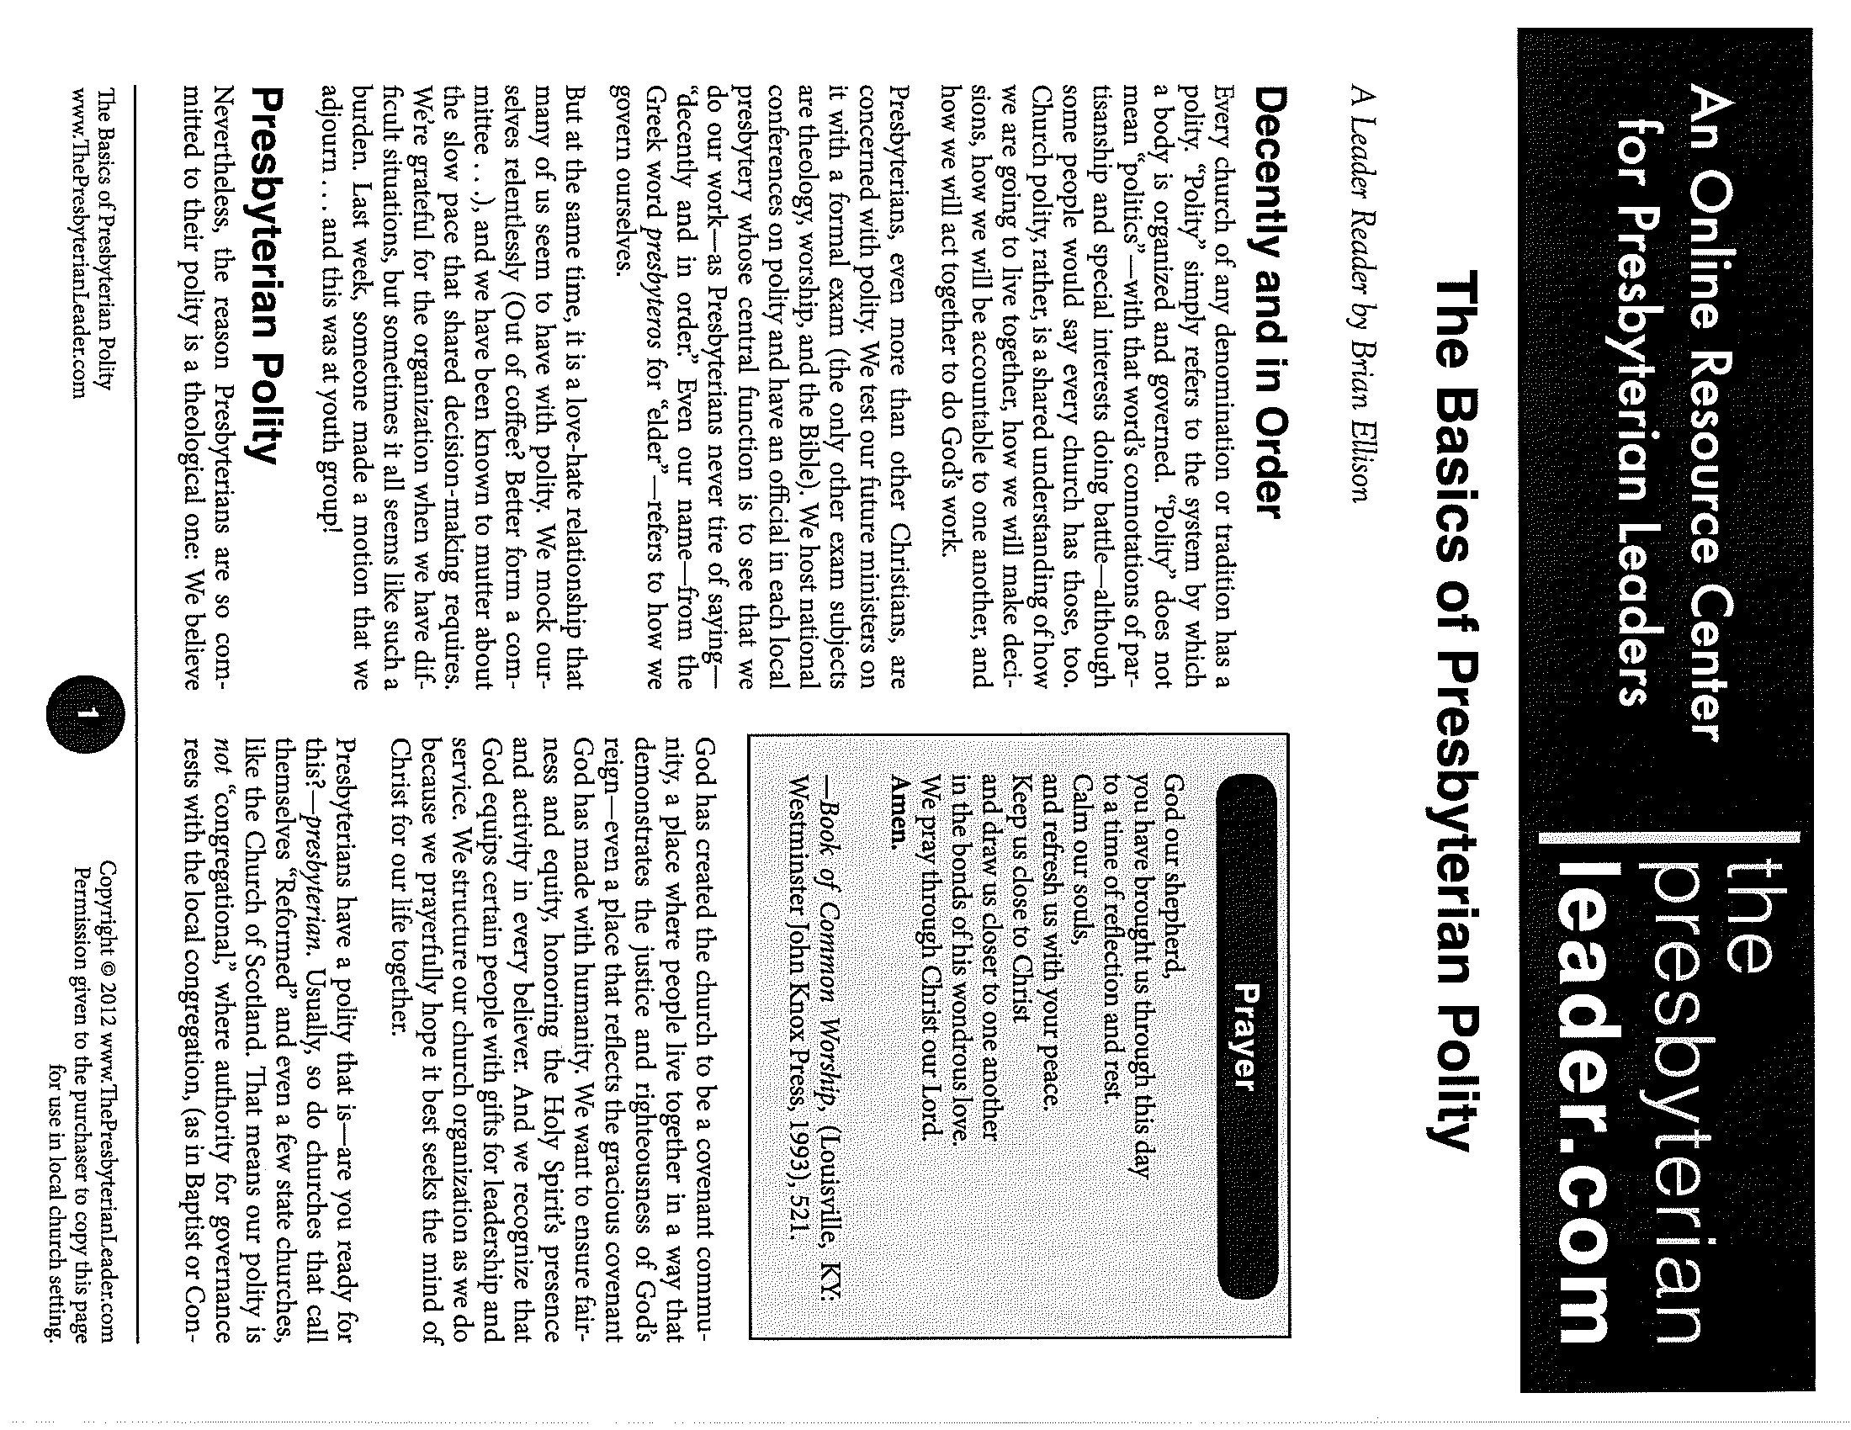
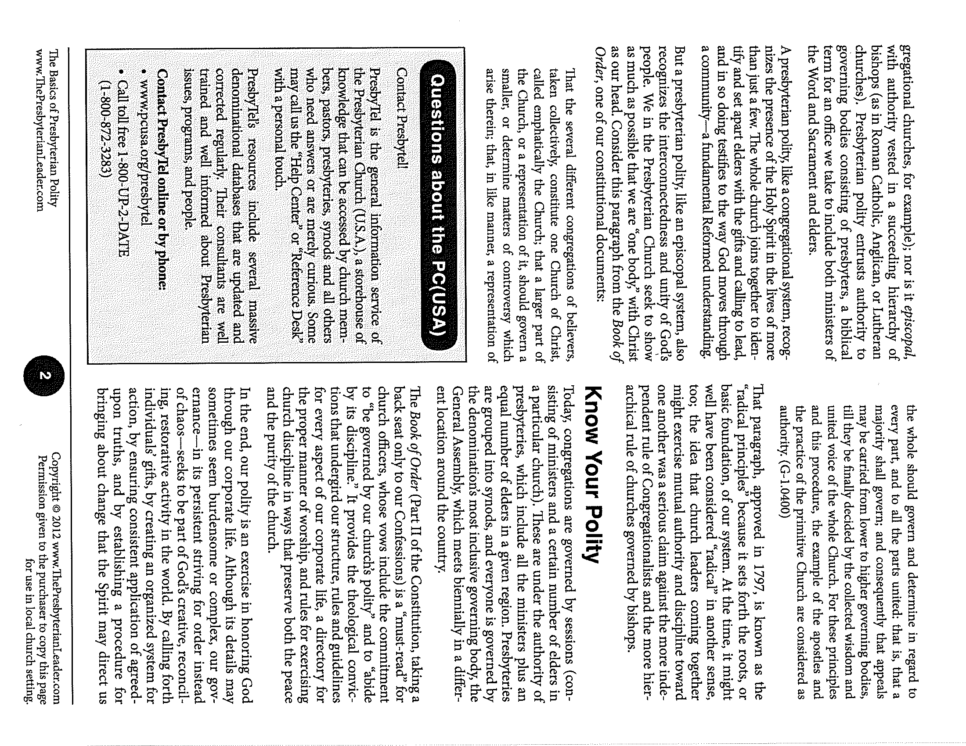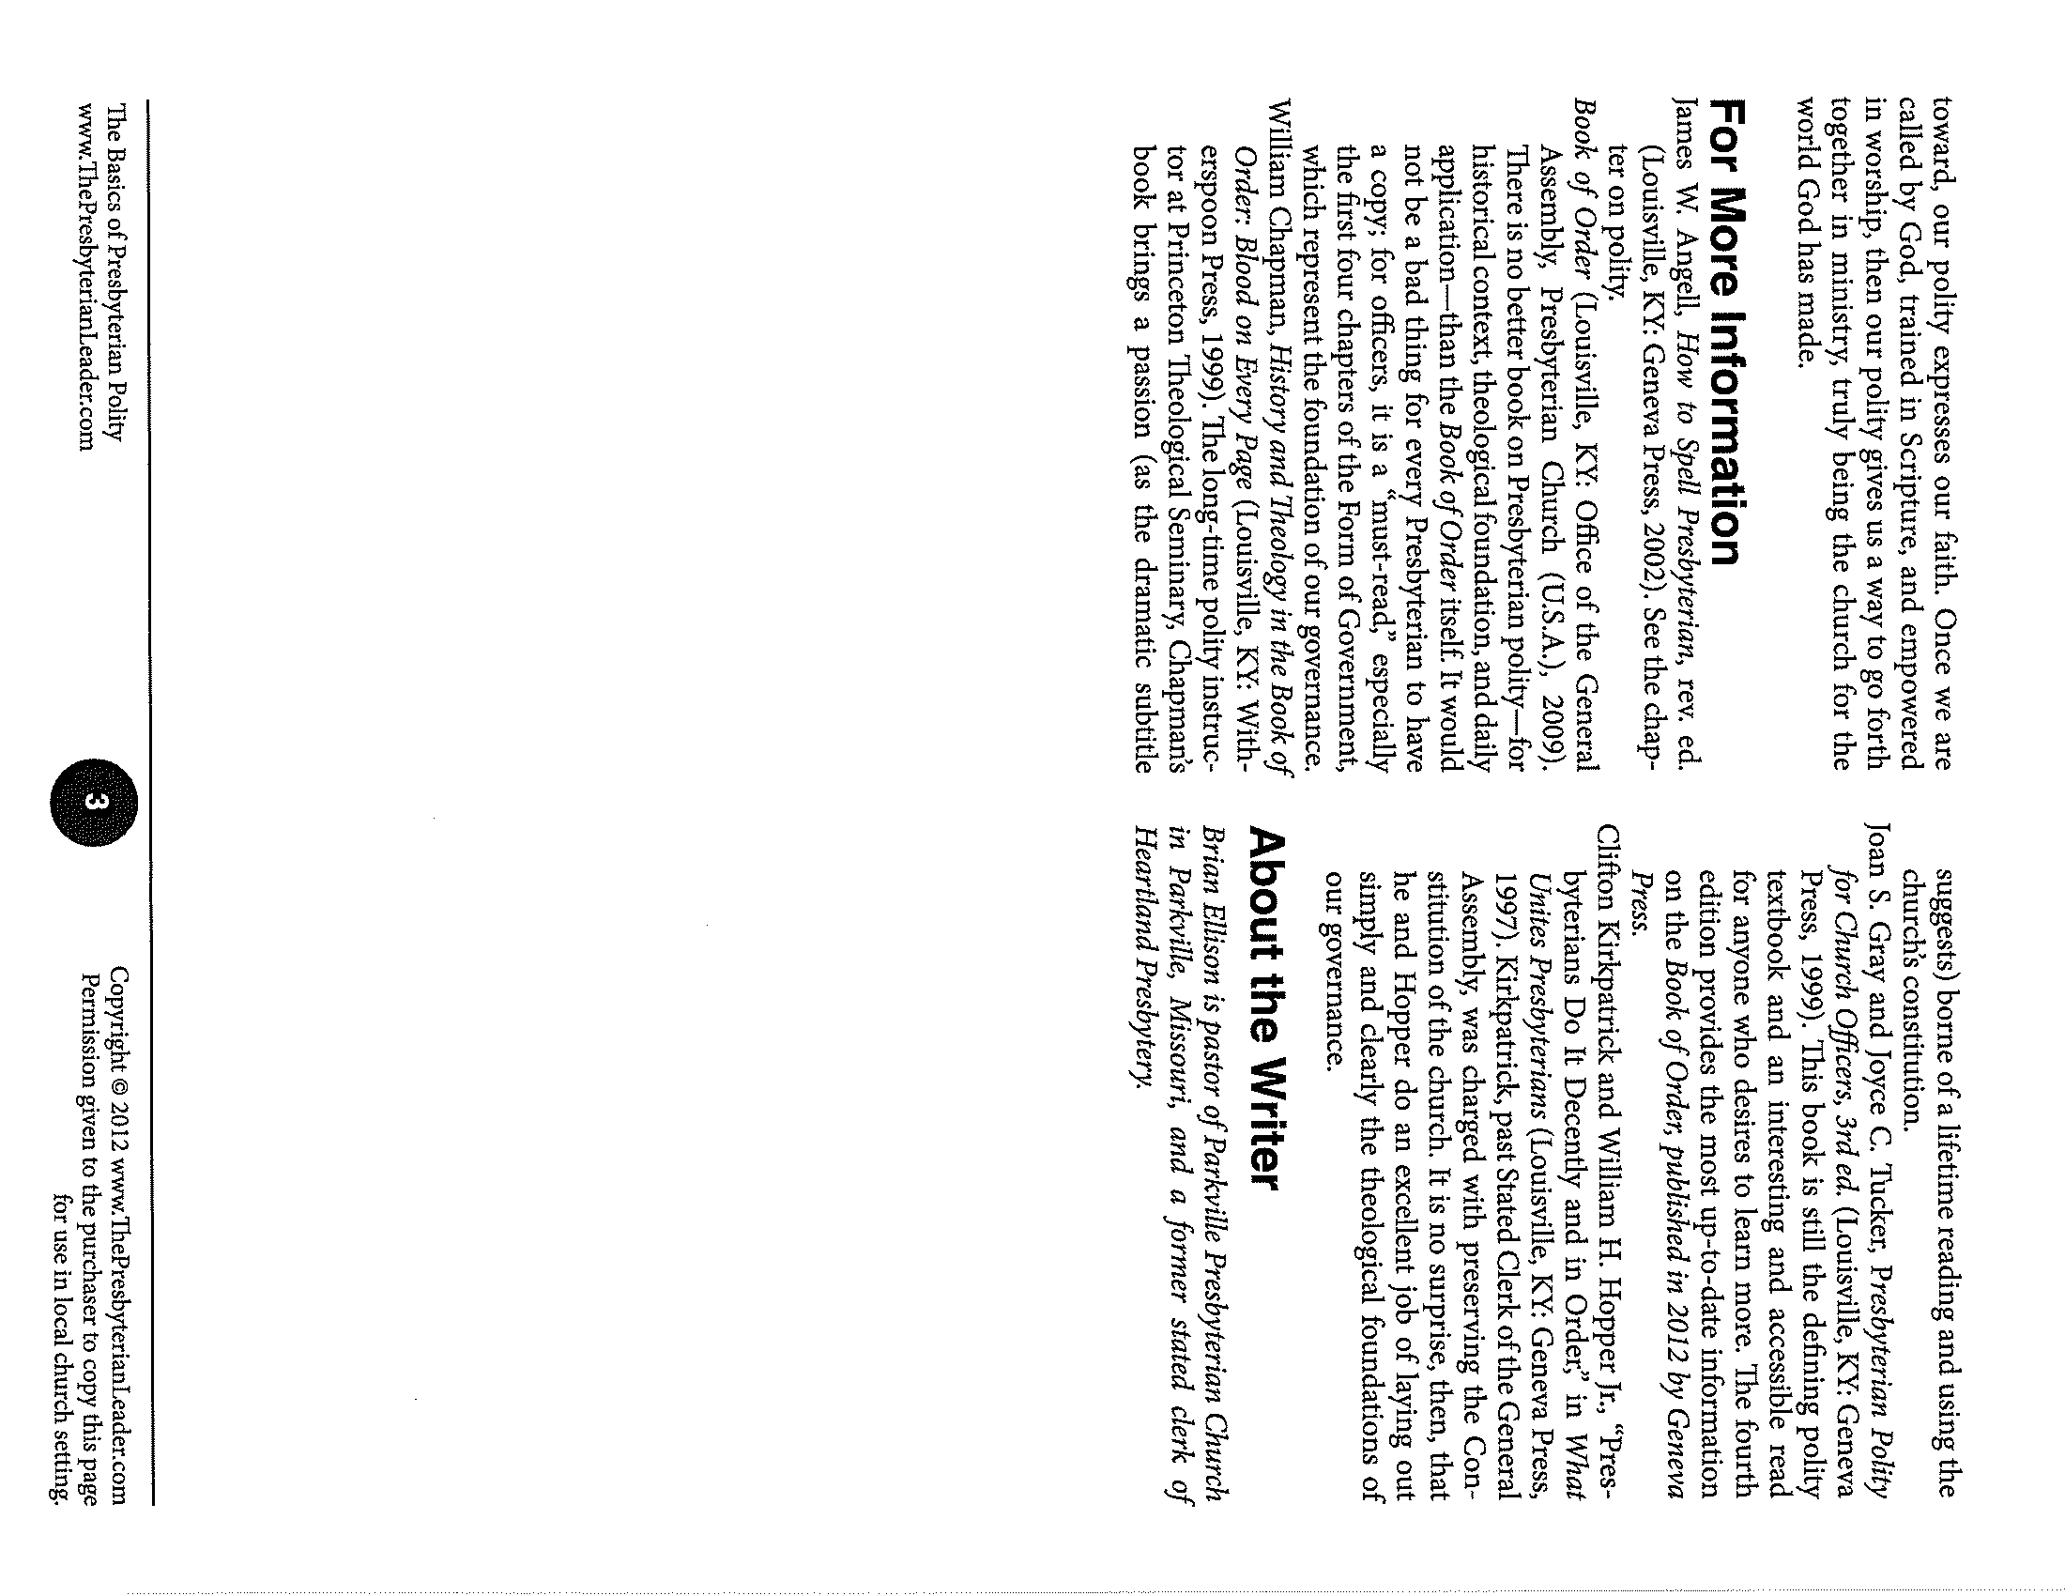

G-3.0104 (Book of Order, The Constitution of the Presbyterian Church (U.S.A), Part II, 2011/2013)
G-3.0104
G-3.0302e

